- PRACTICAL-02
STRACE COMMAND OUTPUTS:
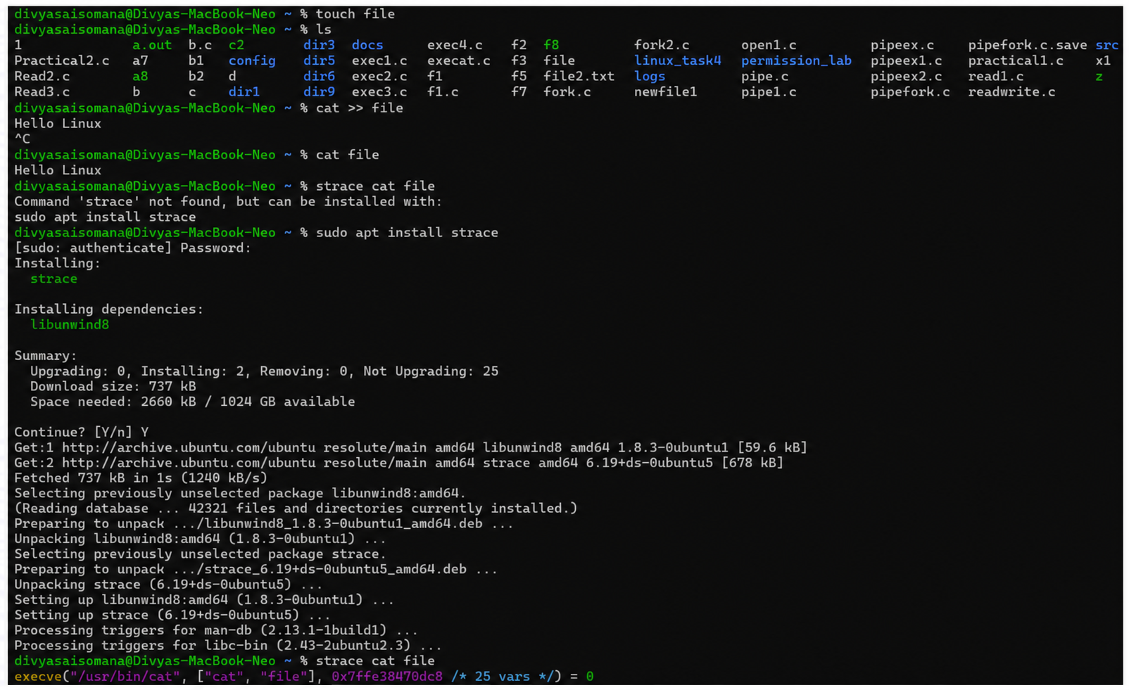
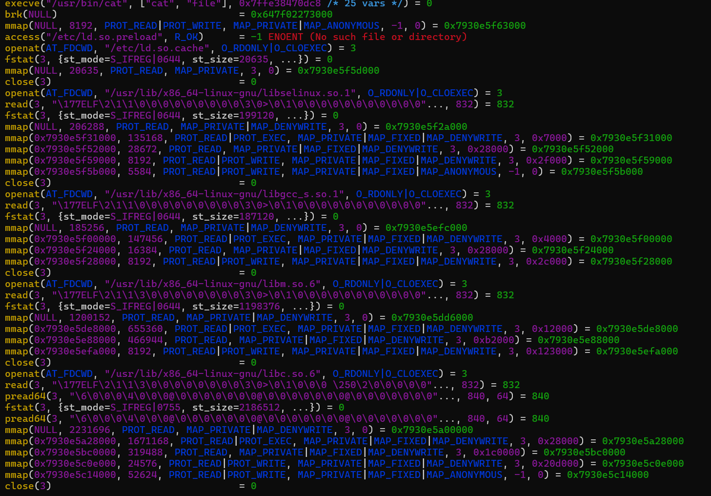
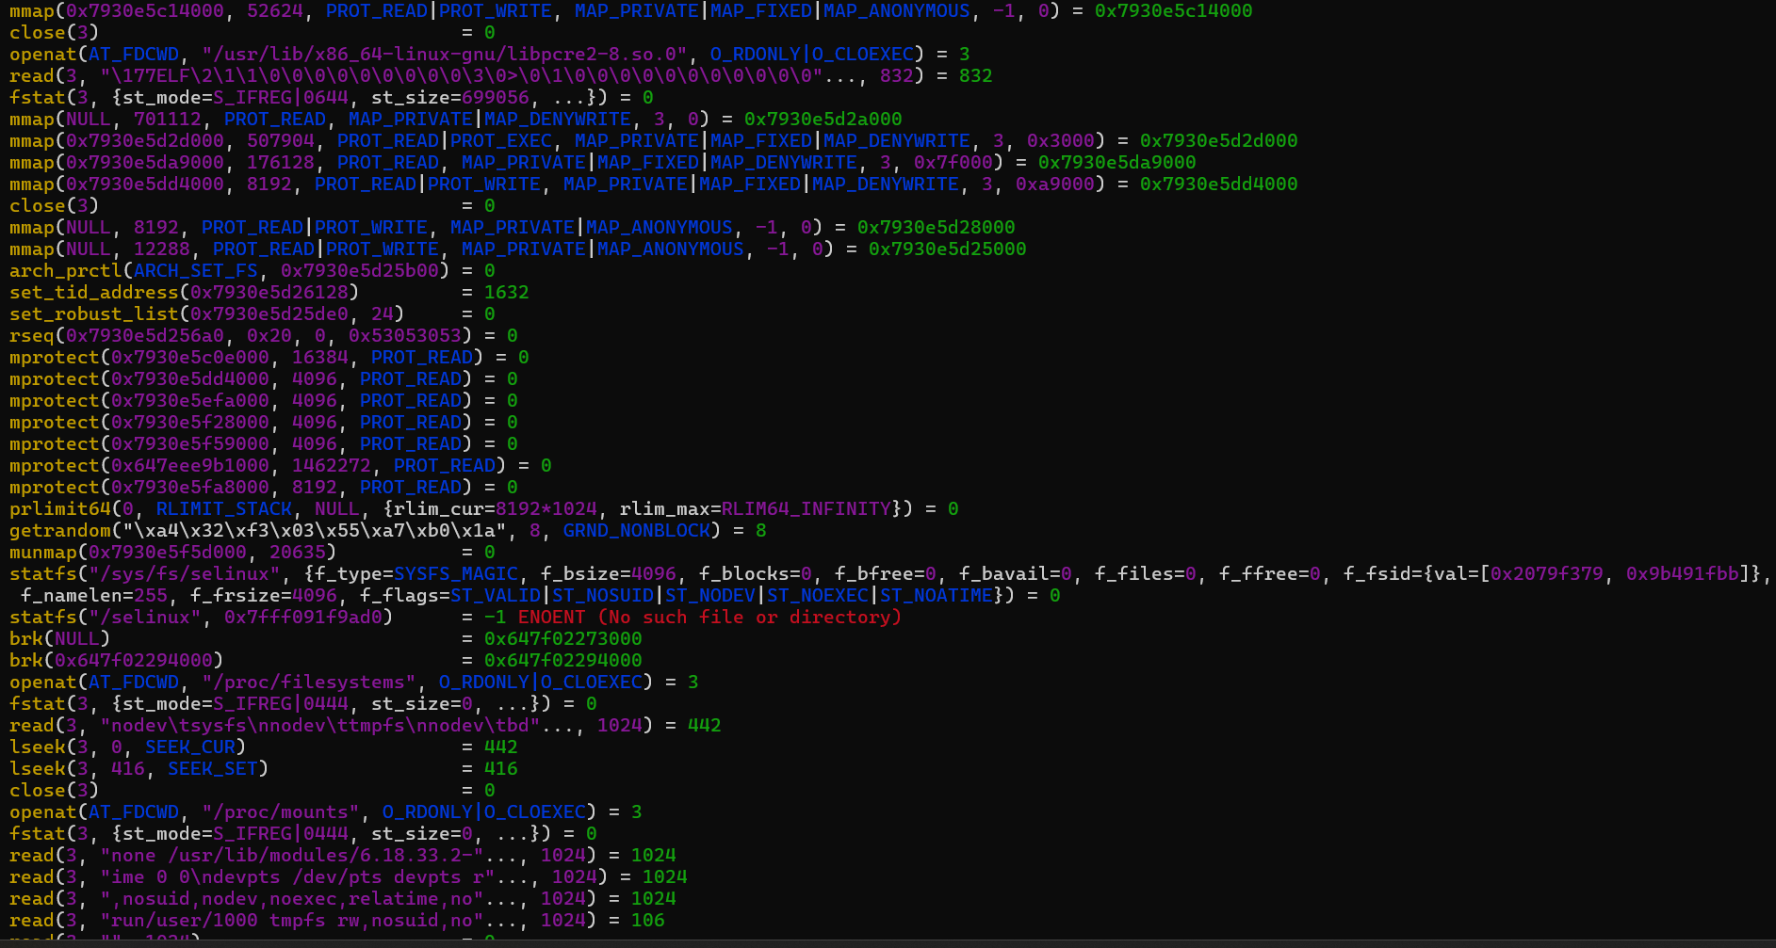
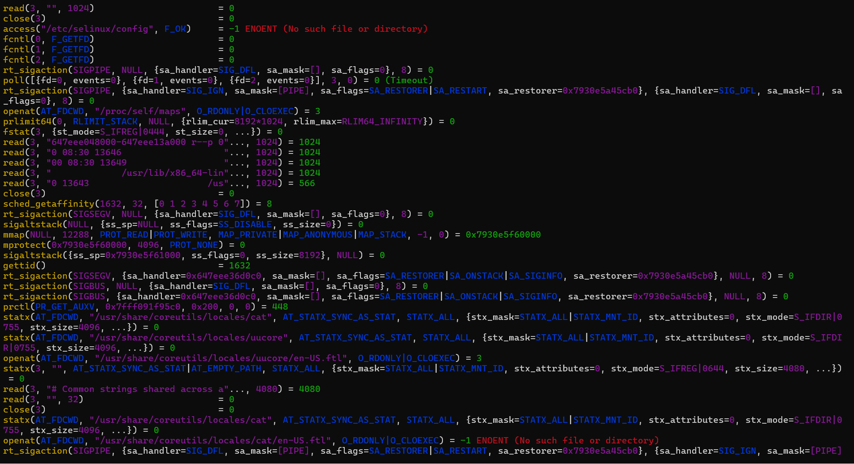
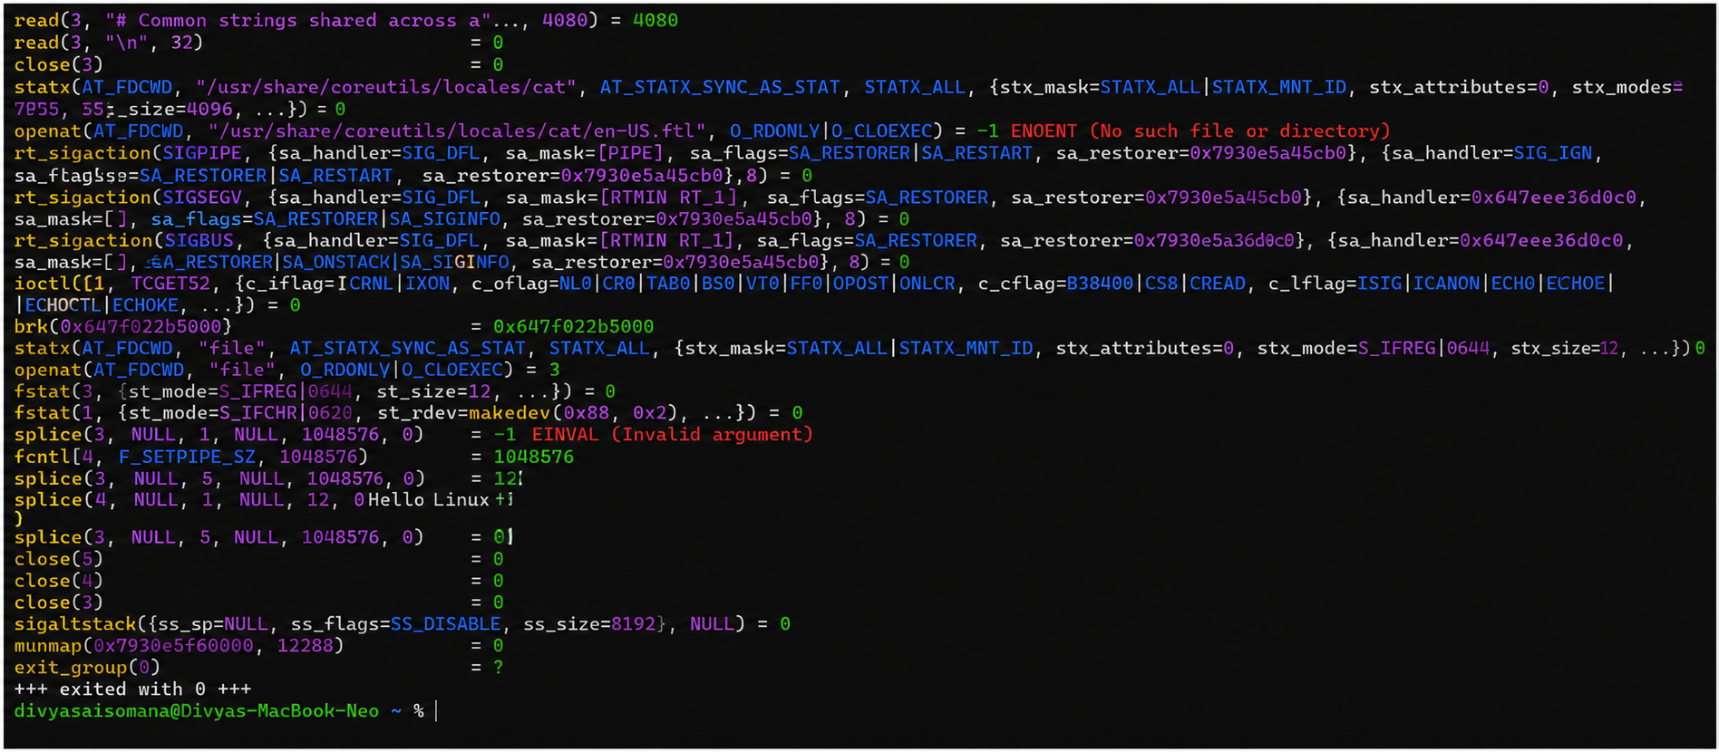
Explain how control transitions between user space and kernel space during execution.
User Space: Applications and user programs execute in user space with limited access to system resources.
System Call: When a program requires an operating system service, it makes a system call.
Mode Transition: The system call causes the processor to switch from user mode to kernel mode.
Kernel Space: The Linux kernel executes the requested operation with access to system resources.
Kernel Processing: The kernel performs the required service and prepares the result.
Return Transition: After completing the operation, control returns from kernel mode to user mode.
Continued Execution: The application continues execution in user space using the result provided by the kernel.

